YEAR END REPORT BY THE INTERNAL AUDITOR
FINANCIAL YEAR ENDING 31 MARCH 2017

Internal Auditor’s Certification to Wigton Town Council

I confirm I have, on the 5th June 2017 undertaken an internal audit for the period 1st October 2016 - 31st March 2017 in accordance with the Account and Audit Regulations (England) 2015 as outlined in the Audit Plan approved by Council and incorporating any new requirements as outlined in “Governance and Accountability for Local Councils” A Practitioners’ Guide (England) March 2016

This report supplements the information reported in the first half -year audit. The council, has received at a meeting of the full council and, responded to all issues raised by BDO following the Audit year ending 31st March 2016. Additionally, the observations of the Internal Auditor in the half-year report have been noted and implemented.

1. Proper Bookkeeping
The core accounts of Wigton Town Council are compiled in Excel spreadsheets. All are totalled monthly and provide comprehensive financial information for the reports of the Responsible Financial Officer(RFO). All monthly and cumulative totals are accurate and are reflected in the year-end accounts.

2. Standing Orders/Financial Regulations/Transparency Legislation.
Standing Orders and Financial Regulations were reviewed and adopted at the meeting held on 8th March 2017 Minute. No. FC129/2016.
See Note 1.

3. Invoice procedure

A random check was made of invoices paid in the period. All adhere to the tendering principles outlined in Financial Regulations.

All comply with the principle of best value.
A random selection was scrutinised examples of which are listed below:_
WTC0395 L. Messenger Allotment Fencing £17527.20
WTC0366 GLL Festivals £ 9809.41
WTC186 Capstick Bedding Plants etc £ 3634.52

4. VAT
Vat has been recorded and the correct sums has been claimed for the period 1st.April 2016 to 31stMarch 2017

5. Sct 137 Payments
Sct 137 payments are correctly identified and recorded. Spend in the current financial year –
British Legion Poppy Appeal - £75.00

6. Risk Management/Security of Documents (Minutes)
The Council received, reviewed and formally adopted Risk Assessment documents, which identified and listed steps to be taken to minimise risks involved in the operation of the council’s policies and financial and physical activities. Meeting 8th February 2017 Minute No. FC/115/2016/1
Minutes are a historical record of the Council resolutions and can be used in a court of law. The security of these and other documents is now ensured by the provision and storage in a secure, locked fireproof cabinet.

7. Internal Financial Controls
Systems are in place to ensure members verify the authenticity of the schedule of cheques, against invoices.

8. Register of Interest
All members fulfil their obligation to update the Register of Interests

9. Budgetary Control
Expenditure is monitored against budget quarterly and the minutes record any required virements.

10. Cash Balances at the Bank
The cash reserves at the bank as at 31st March are unusually high at £186,373.93 however, this does include a capital receipt of £102.114. The Council has earmarked the fund to undertake capital improvements to changing facilities on the Playing Field.

11. Income Controls
Cash income from the operation of the allotments is minimal but is collected and banked in a timely manner.

12. Clerk’s Expenses/Petty Cash
All expenses are reported to council and VAT recovered where appropriate.

13. Payroll Controls

All Payroll records are up to date.

14. Asset Control
The Asset Register was reviewed and updated to include acquisitions during the current financial year.
See Note 2.

15. Bank Reconciliation
Bank Reconciliation’s are regularly carried out on receipt of bank statements. A system has been put in place to ensure compliance with Financial Regulations, which requires a signature of a Member(other than the Chairman) on the relevant bank statement(s), to confirm the accuracy of the information presented by the RFO on the bank reconciliation.

16. Year End Accounts
Wigton Town Council produces accounts on an Income and Expenditure basis as required by the Accounts and Audit Regulations.

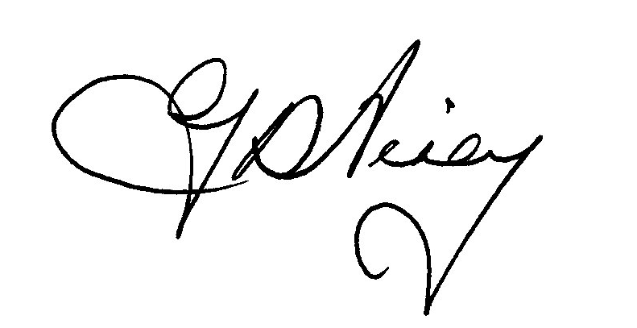Georgina D Airey 5th. June 2017

The following are observations only, with the aim of assisting the council to achieve best practice and/or comply with current legislation.

Issue | Comment | Recommendation
Note 1.  Local Government Transparency Code 2015 | Under the Act Town Councils with and income or expenditure exceeding £200k are required to publish details of how its money is spent, the use of its assets, decision-making and other information on issues important to local people. | A list of all required information has been made available to the Clerk who has undertaken to ensure that the Council becomes fully compliant.
Note 2.  Asset Register | To adhere to the requirement to retain the asset register at known historic cost for Audit purposes, yet ensure the Council has accurate records for insurance value. | A revision of the Asset Register, as discussed with the Clerk, would ensure all requirements are fulfilled.  i.e. Acquisition Cost and Disposal Cost included.

