Wigton Town Council

BARTON LAWS BUSINESS DEVELOPMENT PLAN
www.wigtontown.com

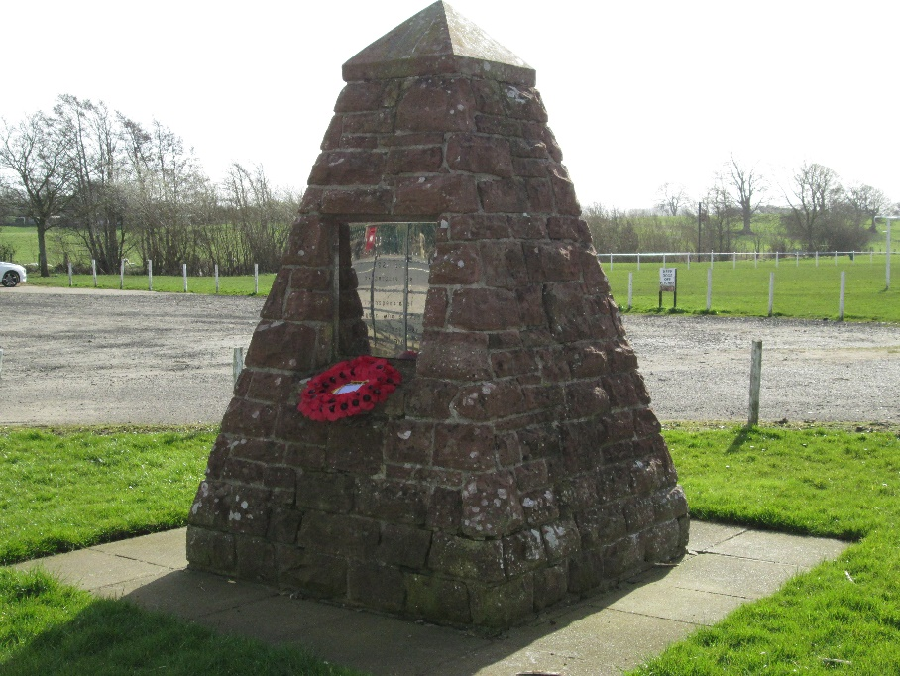

“Protect and Improve Barton Laws for all generations”

“This Playing Field was purchased in 1920 to perpetuate the memory of the townspeople of Wigton who served in The Great War 1914-1918”

Refurbishment and Extension Planned for 2019/20

Wigton Town Council – Commemorating WW1

1. Executive Summary

1.1 Our project is about improving the quality of life for our residents and the wider rural area by improving, protecting, and extending our Recreation Ground and facilities at Barton Laws.
1.2 Barton Laws History: At the entrance to Barton Laws Recreation Ground and Playing Fields is a commemorative pyramid. To the North Side is an inscription “This Playing Field was purchased in 1920 to perpetuate the memory of the townspeople of Wigton who served in The Great War 1914-1918”. Wigton Town Council own the land “in trust” for the people of Wigton.
1.3 Wigton is an historic market town and is designated as a key service centre in the Allerdale Local Plan (Part 1) which was adopted in July 2014. Wigton, during the plan period, “will have developed its role as an important housing, commercial, employment and educational centre in North Allerdale”. One of the strategic policies in the Plan states “Support development which provides and improves open space provision, leisure facilities and recreational areas for young people…..”
1.4 Following consultation with our residents in 2013, Wigton Town Council have included an action to refurbish/extend the changing rooms in The Town Plan as well as improve the recreation ground.

2 Our objective(s)
Our objective is to improve the recreation space and facilities at Barton Laws. This work is split into 4 phases.
2.1 Phase 1: Willow Spilling
Following the floods of December 2015 has resulted in threatening our smaller playing field due to river erosion. Works will be undertaken this spring to repair the bank. The costing of this is approximately £4,500 is to be funded by a grant obtained from Cumbria Community Foundation. Similar works were carried out on a different stretch of the river bank in 2011.
WORKS NOW COMPLETED
2.2 Phase 2: The refurbishment/extension of the current pavilion/changing room.
A condition survey carried out in 2014 determined that the building is basically sound but showing its age under heavy usage and requiring complete renovation if it is to remain in use.
Plans have been drafted to refurbish and extend the premises to meet current specifications. Costs are anticipated to be around £4000.00 Providing improved facilities will help us to underpin our existing community events whilst helping further develop new ones which is a vital ingredient in a healthy and positive community environment and further cement community cohesion.
Councillors have resolved to progress this project, following a recommendation from the Finance committee. To date the following funding streams have indicated “in principle” the following amounts:
- Football Foundation £75000.00
- Allerdale Borough Council Sec 106 monies £20,000
- Wigton Town Council £100000.00
- Allerdale Borough Council £50000.00
Other bids for funding will be submitted and we continue to research other funding streams.
2.3 Phase 3: Bailey bridge
The erection of the “Bailey Bridge” over the River Wiza to connect and give access to land owned by the Town Council.
2.4 Phase 4: Re-assess opens space requirements
To reassess open space requirements with regard to any designated use of the additional land.

3. Community needs
3.1 Current users of the playing fields/pavilion are
- Wigton Harriers FC
- Abbeytown Football Teams
- The Annual Carnival
- Ad-hoc community events (e.g. Guinness World Record Attempt and Amourial Knights)
- Police dogs exercise.
- Whippet schooling/ Whippet Racing
3.2 Barton Laws has seen an increase of team users from 2 teams in 2015/16 to 9 teams currently
3.3 The beneficiaries will include local sport and leisure groups especially those that are volunteer led that are promoting and contributing to the overall health and wellbeing of our community. We have engaged with our local running club, youth provisions and young people who have all expressed interest in using the facilities throughout the year.
3.4 The project will also help new initiatives within our community such as the burgeoning re-establishment of our local Rugby League club
3.5 Another key beneficiary will be our elderly. “The Cumbrian population is ‘super ageing’. By 2020 nearly 25% of the Cumbrian population will be aged over 65” (JSNA 2015 onwards). The project will provide access to both social and leisure services to our elderly through a number of channels. We will actively engage with key partners in our community such as Age UK to promote active living such as walking football and rounders, whilst helping to combat the growing problems of both social and rural isolation within both our community and the outlying hinterlands.
3.6 The project will also benefit members of our community that are disabled that currently cannot access the facility due to lack of disability access. The improved facility will help empower these members and help them actively participate in activities in their community.

3.8 SWOT Analysis
The key issues surrounding the condition of the present facilities are supported by a SWOT analysis:
Strengths  - Regular bookings and increased demand  - Supports not only the Town but our Hinterland (key service centre)  - Interest expressed from community groups to use “modern” facilities  - Running costs guaranteed by the Town Council | Weaknesses  - Poor state of repair, poor facilities  - No facilities for the disabled  - Inefficient heating system  - No kitchen, sub-standard toilets  - Unsuitable storage  - Corroded steel lintels  - Inefficient insulation
Opportunities  - Community need identified  - Improved facilities will attract other community groups in the future  - Wider social benefits  - “Pride in Wigton” | Threats  - Reduced hiring due to deteriorating facilities  - Threatened closure due to deteriorating facilities  - Failure to comply with H & S requirements

4. The Future
4.1 Options Appraisals
Three Options were considered
- Do Nothing. Although this is the lowest cost option this valued community asset is locked in a downward spiral ultimately leading to its demise. Year on year additional problems occur with the facilities due to lack of maintenance/upgrading. Ultimately non-action will lead to its closure.
- Refurbish the existing building. Whilst this would be the most cost effective option, the building would not meet required standards, such as access for the disabled, referee’s facilities and only cope with one match at a time. There would be insufficient space for additional community use.
- Refurbish and Extend. Refurbishment of the existing building would guarantee its life for the next generations and the extension would provide room to support two events at a time, suitable access for the disabled, public toilets and a raised efficient plant room. Flexible space will appeal to various groups, providing access to both social and leisure services.
Option 3 was agreed by The Town Council and draft plans were commissioned.
4.2 The Project.
Project costings are detailed on a separate sheet

4.3 Risk Analysis
The following table analyses the risks associated with the project;

Risk | Risk Probability | Risk Impact | Risk Reduction
Failure to attract sufficient funding | Medium | Low | Preparation of high quality directed bids. Town Council will under-write project as a last resort. Potential to take out loan
Project Manager becomes unavailable | Low | Low | Employment of professional company to manage project (included in fees above)
Failure to secure Planning Permission in perpetuity | Medium | Medium | Pre-planning discussions to proceed. Worst case scenario refurbishment of existing building footprint
Builder goes into liquidation | Low | Medium | Selection of well-established company. Regular staged payments
Unexpected Crisis arises | Low | Medium | Project Manager in place. Escalated to Footpaths and Parks Committee if not resolved/& or Full Council

4 Managing the Project
The Project will be managed by xxxxx, whose fees are xxxx. They will liaise closely with the Clerk to Wigton Town Council and the overseeing committee.

Draft – April 2019

